1. Design a html form of your choice to illustrate different input controls.

<html>

  <head>

    <title>inputControls</title>

  </head>

  <body>

    <form action="" style="margin: 10px; padding: 10px;">

      <label for="Name"

        >Name:<input type="text" name="Name" size="30" />

      </label>

      <br />

      <br />

      <label for="ProfilePic"

        >Profile Picture:

        <input type="file" name="ProfilePic" accept="image/\*" />

      </label>

      <br />

      <br />

      <label for="userId" style="padding-right: 10px;">

        UserId: <input type="text" name="userId" />

      </label>

      <label for="password">

        Password: <input type="password" name="password" />

      </label>

      <br /><br />

      <label for="Address"

        >Address: <textarea name="Address" id="" cols="30" rows="5"></textarea>

      </label>

      <br />

      <br />

      <h3>Hobbies</h3>

      <label for="Hobbies" style="padding: 10px;"

        ><input type="checkbox" />Reading</label

      >

      <label for="Hobbies" style="padding: 10px;"

        ><input type="checkbox" />drawing illustrations</label

      >

      <label for="Hobbies" style="padding: 10px;"

        ><input type="checkbox" />Playing instruments</label

      >

      <label for="Hobbies" style="padding: 10px;"

        ><input type="checkbox" />Travelling</label

      >

      <br />

      <h3>Gender</h3>

      <label for="Gender" style="padding: 10px;"

        ><input type="radio" name="Gender" value="Male" />male</label

      >

      <label for="Gender" style="padding: 10px;"

        ><input type="radio" name="Gender" value="Female" />Female</label

      >

      <br />

      <br />

      <label for="Profession">

        <span>Profession: </span>

        <select name="Profession" id="prof">

          <option value="Student">Student</option>

          <option value="Worker">Worker</option>

          <option value="Business Owner">Business Owner</option>

        </select>

      </label>

      <br />

      <br />

      <br />

      <input type="submit" name="submit" value="Submit" />

      <input type="reset" name="reset" value="Reset" />

    </form>

  </body>

</html>

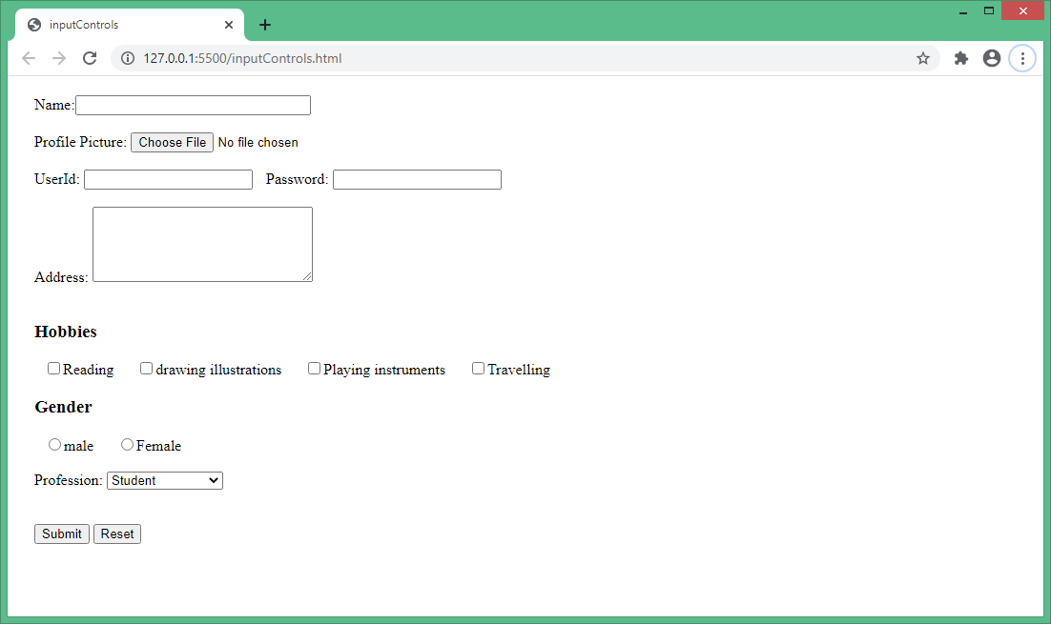

1. Using HTML form tags design a railway reservation form

<html>

    <head>

        <title>railway reservation form </title>

    </head>

    <body>

    <form name="railway">

        <h1> Railway Reservation form </h1>

     <table>

     <tr>

         <td>From:</td>

         <td><input type="text" name="railway"></td>

         </tr>

     <tr>

     <td>To:</td>

     <td><input type="text" name="txt2"></td>

     </tr>

        <tr>

                <tr>

                    <td>Time:</td>

                    <td><input type="time" name="time"></td>

                </tr>

            <tr>

                <td>Date:</td>

                <td><input type="date" name="date"></td>

            </tr>

            <td>Name:</td>

            <td><input type="text" name=""></td></tr>

         <tr>

         <td>Age:</td>

         <td><input type="number" name=""></td>

         </tr>

         <tr>

         <td>Address:</td>

         <td><input type="text" nqme=""></td></tr>

          <tr>

          <td>Payment options:</td>

         <td>

          <input type="radio" name="payment" value="cc" />Credit Card <br />

<input type="radio" name="payment" value="dc" />Debit card <br />

<input type="radio" name="payment" value="wallet">wallet<br/>

        </td>

          <tr>

           <td><input type="submit" value="submit"></td>

           <td><input type="submit" value="Cancel"></td></tr>

         </table>

    </body>

</html>

